Name : K Jahnavi
Reg no: 192512169
Ex.No:1: Simulation of FDMA in MATLAB
Aim: To simulate a Frequency Division Multiple Access (FDMA) system using MATLAB and analyze its communication performance in terms of channel bandwidth, data rate, and signal-to-noise ratio (SNR).
Objective:
Objective 1: To simulate an FDMA system by allocating individual frequency channels to multiple users and determine the channel bandwidth assigned to each user. Output Parameter: Channel Bandwidth (kHz)
Objective 2: To calculate the data rate achieved by each user in the FDMA system based on the allocated channel bandwidth. Output Parameter: Data Rate (kbps)
Objective 3: To evaluate the communication quality of the FDMA system by calculating the Signal-toNoise Ratio (SNR) for different users.
Procedure:
clc; clear; close all;
fs=1000; t=0:1/fs:1;
TBW=600; Users=3;
CBW=TBW/Users;
fc=[100 300 500];
m=sin(2*pi*10*t);
s1=m.*cos(2*pi*fc(1)*t);
s2=m.*cos(2*pi*fc(2)*t);
s3=m.*cos(2*pi*fc(3)*t);
subplot(2,1,1)
plot(t,s1,'r',t,s2,'g',t,s3,'b',"Color","r"),
grid on
title('192512216 FDMA Channel Allocation')
xlabel('Time (s)'),
ylabel('Amplitude')
subplot(2,1,2)
bar(1:Users,CBW*ones(1,Users),"g"),
grid on
xlabel('Users'),
ylabel('Channel Bandwidth (kHz)'),
title('192512216 Channel Bandwidth per User')
Output:
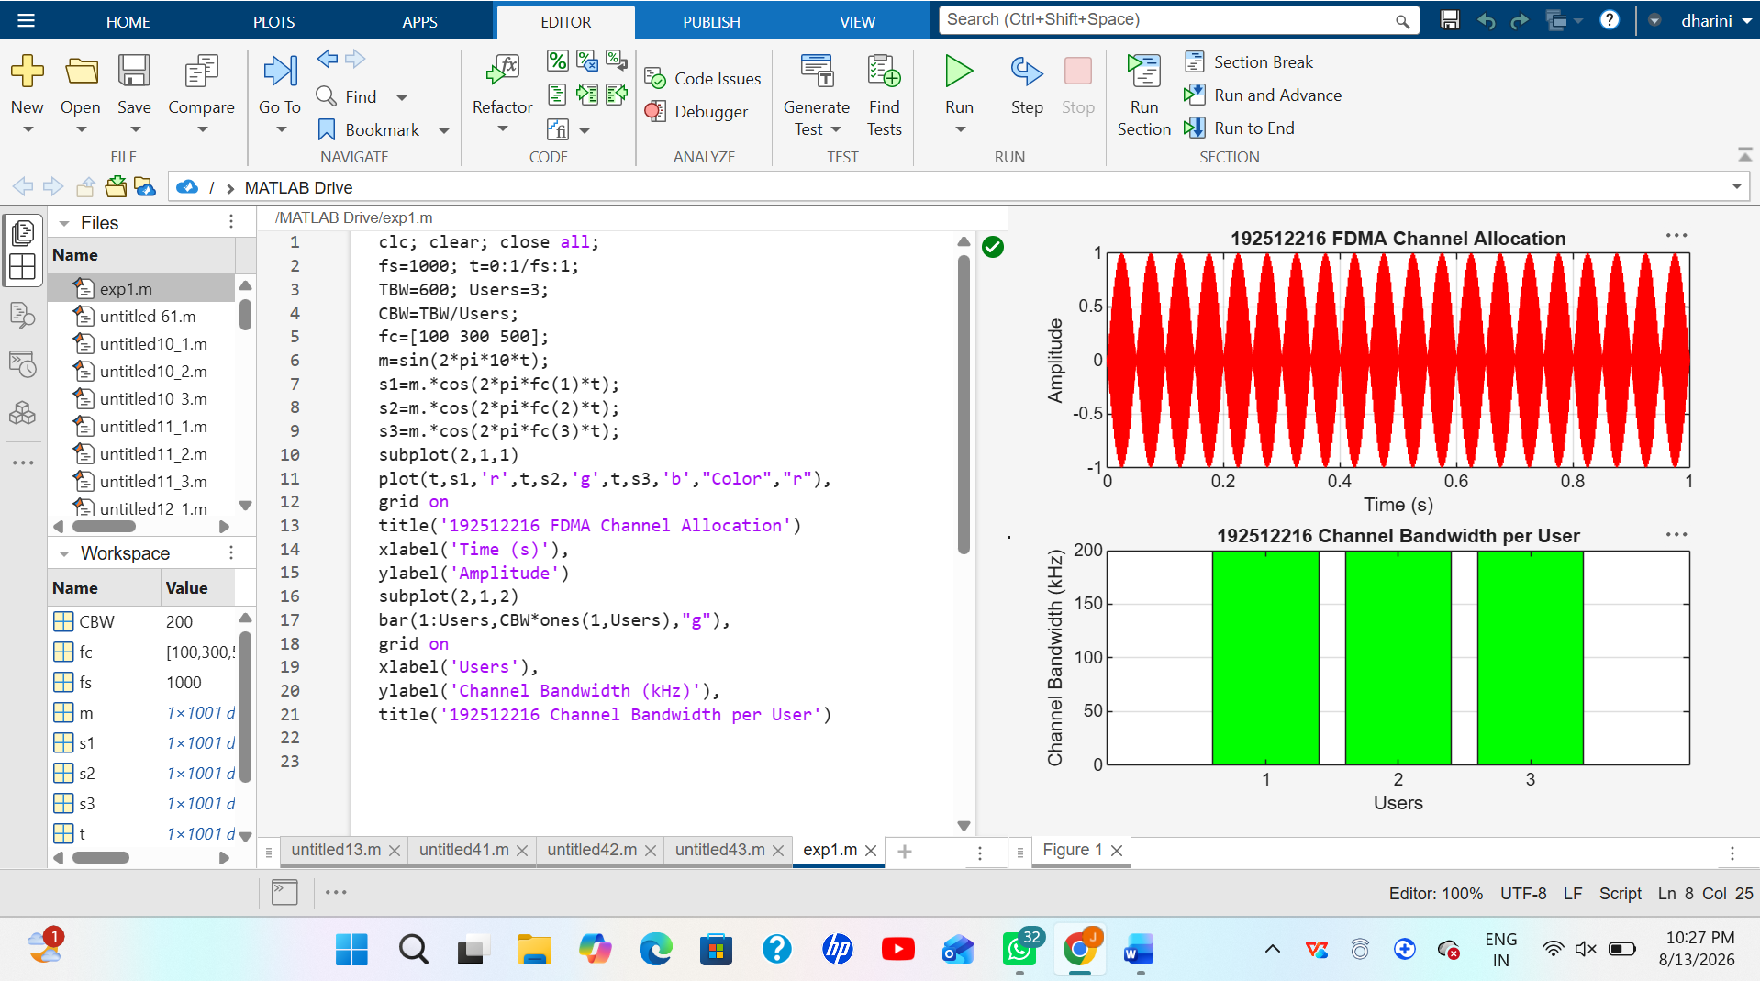
Objective 2:
clc; clear; close all;
BW = 200;
Users = 3; M = 2;
% Channel Bandwidth (kHz) % BPSK Modulation
DataRate = BW*log2(M); % Data Rate (kbps)
Rate = DataRate*ones(1,Users);
disp(' User Data Rate (kbps)')
disp([(1:Users)' Rate'])
figure
bar(1:Users,Rate)
xlabel('Users')
ylabel('Data Rate (kbps)')
title('FDMA Data Rate for Each User')
grid on
Output:
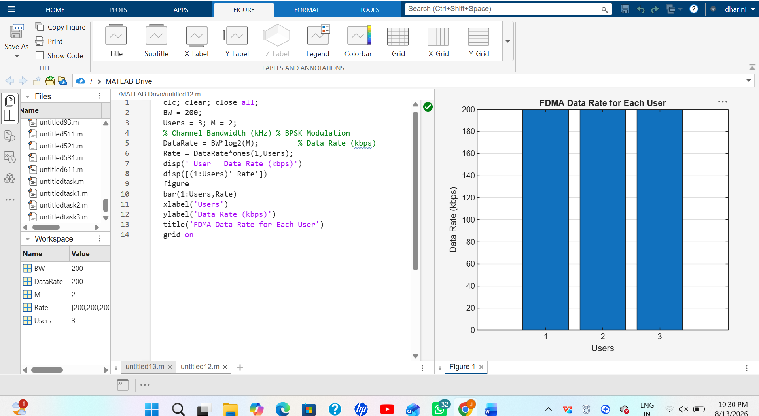
Objective 3:
clc; clear; close all;
Ps = 1;
Pn = [0.1 0.05 0.01]; % Signal Power (W) % Noise Power (W)
Users = 1:3; SNR = 10*log10(Ps./Pn); % SNR in dB
disp('User Noise Power(W) SNR(dB)')
disp([Users' Pn' SNR'])
figure
bar(Users,SNR,"black")
xlabel('Users')
ylabel('SNR (dB)')
title('Signal-to-Noise Ratio of FDMA Users')
grid on
Output:
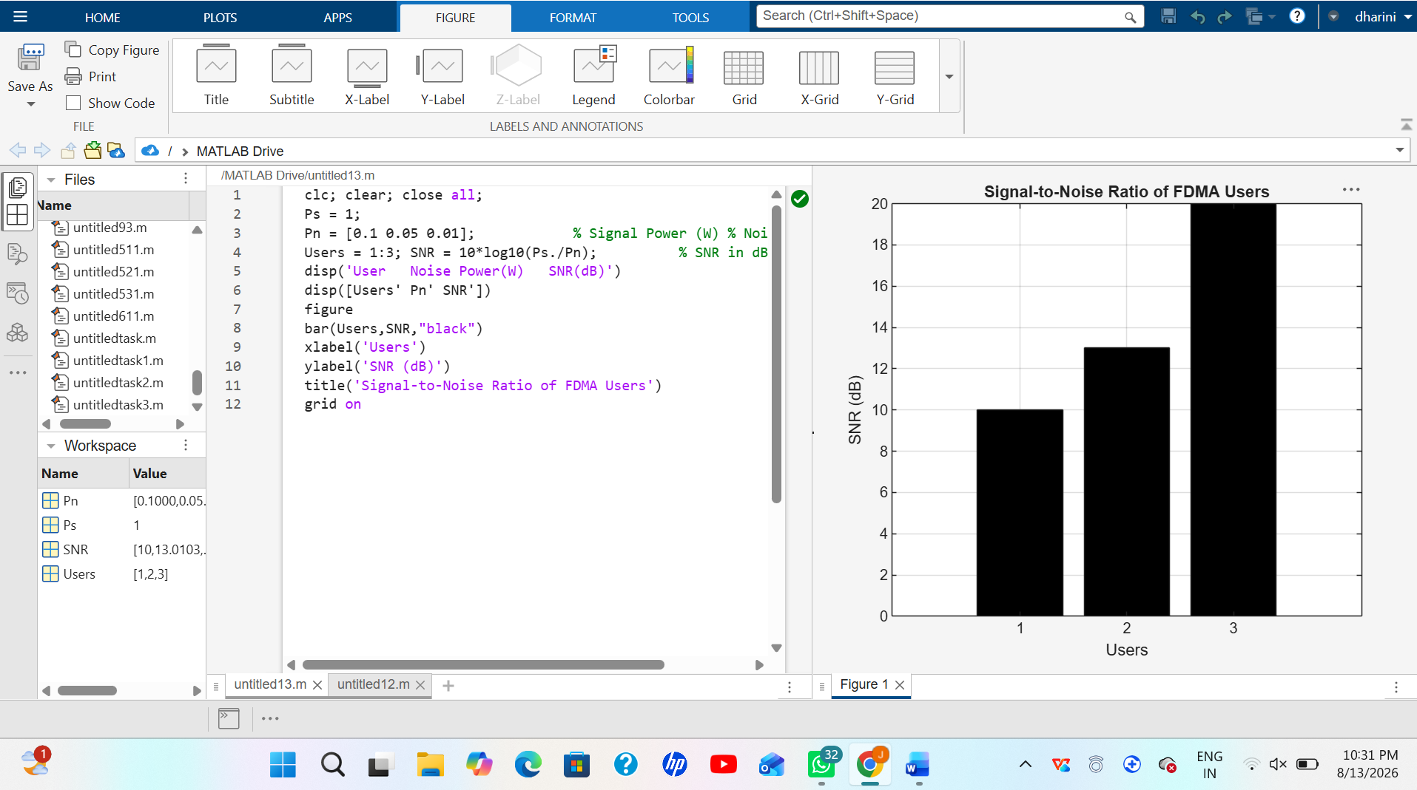
Result:
1. The FDMA system was successfully simulated by allocating separate frequency channels to three users, and the channel bandwidth assigned to each user was determined.
2. The data rate achieved by each user was successfully calculated based on the allocated channel bandwidth, demonstrating equal transmission capacity for all users.
3. The Signal-to-Noise Ratio (SNR) for different users was successfully evaluated, showing that higher SNR values provide better communication quality and reliable data transmission.

